- What is Helm Chart?
- Why we need Kubernetes?
- How Helm chart will help us to manage K8s?
- How to install Helm chart?

What is Helm Chart?
A Helm Chart is a collection of files that describe a set of Kubernetes resources. Helm is a package manager for Kubernetes, and a Helm Chart is the packaging format it uses. Helm Charts simplify the deployment, scaling, and management of applications in a Kubernetes cluster by allowing you to define, version, and share Kubernetes application configurations in a standardized way.

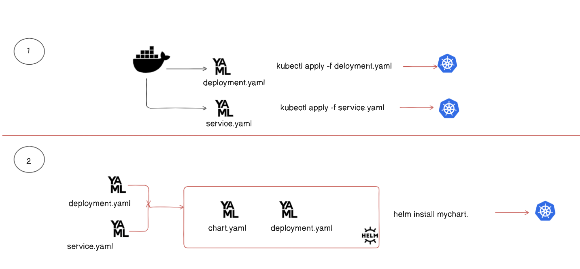

Why we need Kubernetes?

- Scalability - You cannot scale single container to server millions of request.
- Automate Docker Deployment - k8s can he manage automate the docker deployment.
- Auto-Healing - If a container is not healthy then k8s can auto replace the container.
- Rollout & Rollback - k8s monitors the unhealthy docker container and restart unresponsive.
A rollout is the process of deploying a new version of an application or workload to the Kubernetes cluster. It typically involves updating the containers running in Pods to a newer version.
A rollback reverts the Deployment to a previous version if a rollout fails or introduces issues. Kubernetes stores the history of Deployment revisions, allowing you to switch back to an earlier, stable.

How Helm chart will help us to manage K8s?

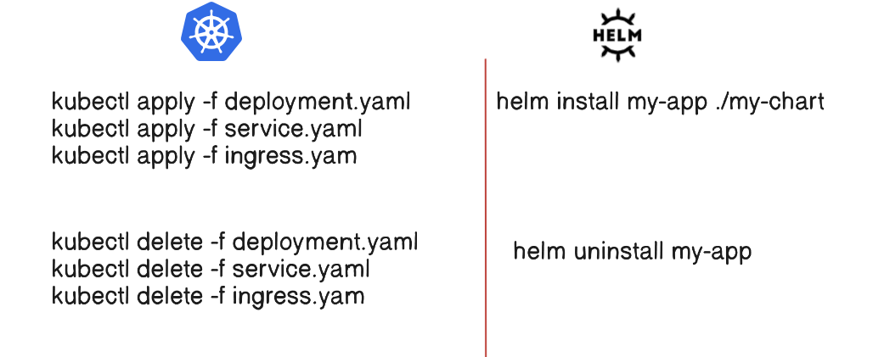

Installing Helm Chart with Pre-requisites

Pre-requisites
- One running Kubernetes cluster:
You need any of the following:
  - EKS: Amazon Elastic Kubernetes Service
  - GKE: Google Kubernetes Engine
  - AKS: Azure Kubernetes Service
  - microk8s: Lightweight Kubernetes for local development (used for this demo).

Microk8s installing in ubuntu through microk8s documentation
https://microk8s.io/docs/getting-started
sudo apt update -y
sudo snap install microk8s --classic --channel=1.31

Join the group
sudo usermod -a -G microk8s $USER
mkdir -p ~/.kube
chmod 0700 ~/.kube

su - $USER or newgrp microk8s

microk8s status --wait-ready
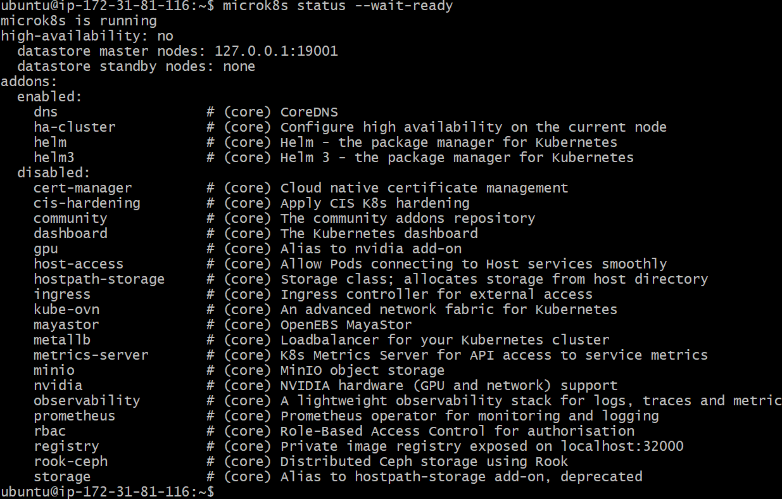

Install kubectl

sudo snap install kubectl --classic
or
follow document
https://kubernetes.io/docs/tasks/tools/install-kubectl-linux/#install-kubectl-binary-with-curl-on-linux

microk8s kubectl get services
alias kubectl='microk8s kubectl'

install HELM in ubuntu

